Filming Tips:

- Overall focus: Capture the interaction. (This isn’t film-making, merely capturing for learning/training purposes)
- As much as possible, keep the “triangle” of interaction in the frame (child, adult, activity).
  - NOTE: Try to capture facial expressions
- Except in rare cases, no zoomed-in shots of the child.
- Keep the videos to about 2 minutes or less and no more than 5 minutes. (Feel free to stop recording and immediately begin recording again within the same interaction.)
- No need to ever capture a child in the absence of the adult.
- Once you have the shot properly framed, keep the camera in the same place and steady as much as it is physically possible -- move the camera only if you need to follow a moving subject or you are obstructed (for example, if a child blocks it).
  - TIP: create a tripod with your arm
- To charge the camera and upload the videos, use the cord included with the camera.

Video Editing Outline:
Windows MovieMaker: This is the software that we use to edit our videos. It comes already installed on many personal computers and is easy to download online. This is, from what we have found, the best and easiest method to editing videos (especially inserting captions).
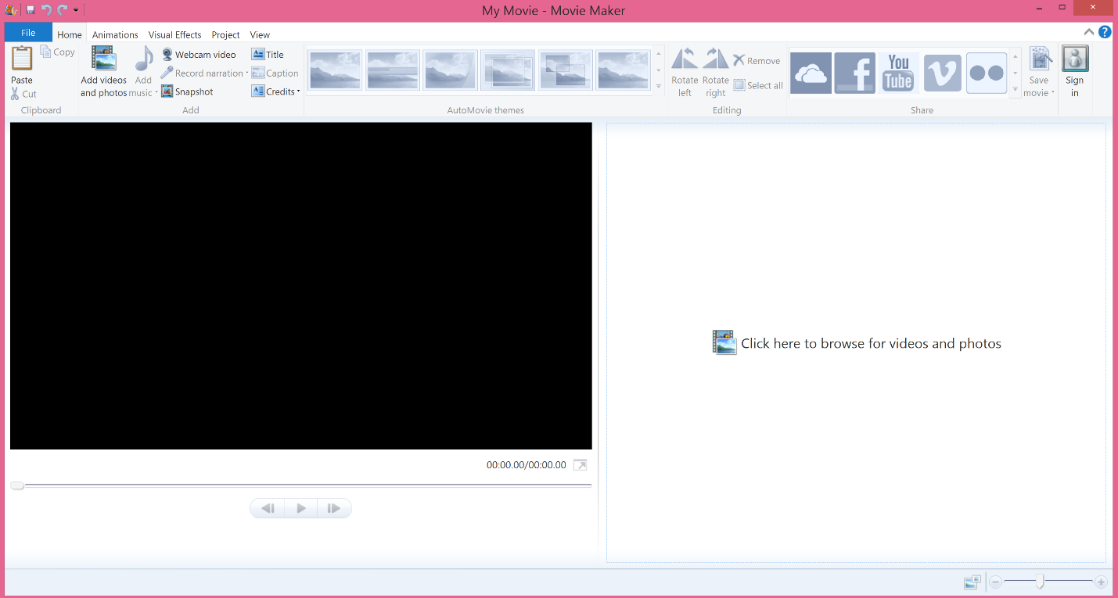
Importing Videos: There are two options for importing videos into Windows Movie Maker.
First, click on “Add videos and photos” or “Click here to browse for videos and photos” and then choose the video or videos to work with.
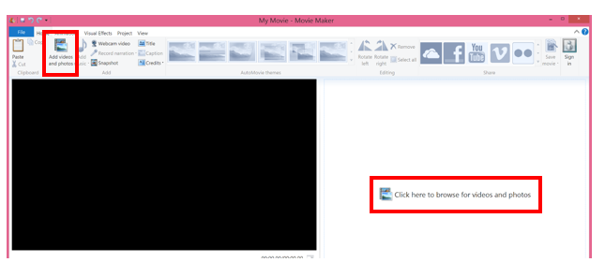

Second, just drag videos from the folder or desktop into the editing screen.

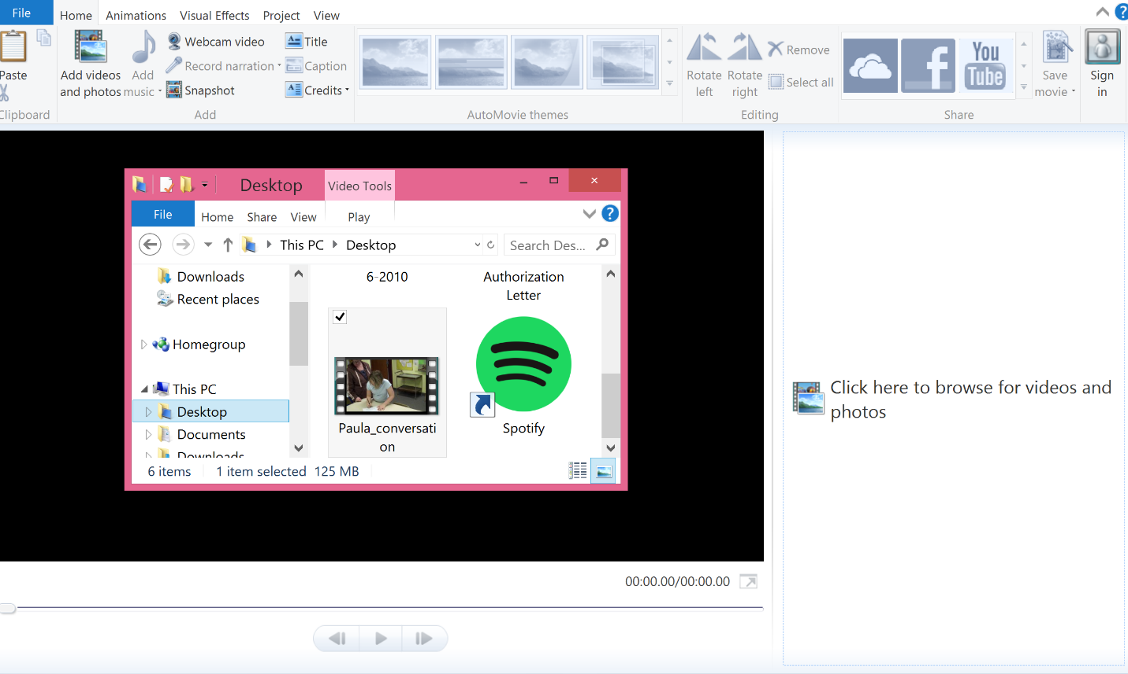

Adjusting Video Sound and Volume: It is important that the narration is the primary focus of the video, therefore, we must choose to emphasize the narration in all our video clips.

Project Emphasize narration

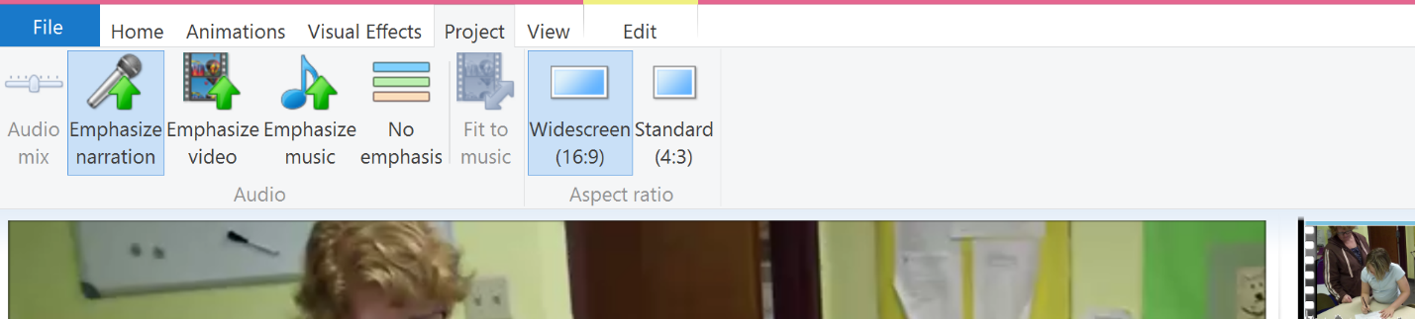

We also need to make sure that the audio is loud enough. Therefore, we can adjust the video volume. [NOTE: If the video is loud enough or filmed in an area with wind or echoes (i.e. outside or in the gym) there is no need to increase the volume]

Edit Video Volume (slide to appropriate volume)

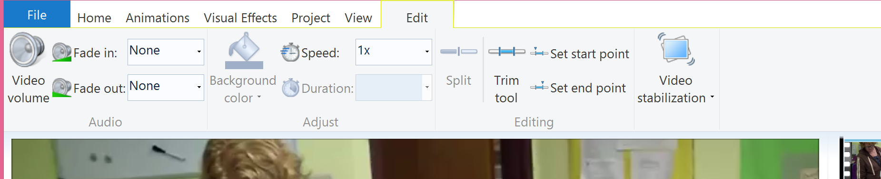

Splitting Videos: This is an important tool when we want to trim multiple parts of the same video clip. This tool allows us to split the single video clip into multiple parts that can then be trimmed accordingly.

Drag the bar along the video board, on the right, to the location where you want to split the video and then go to:
Edit Split

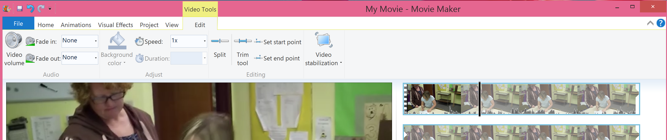

EXAMPLE:
Given these edits, we could make the following splits:
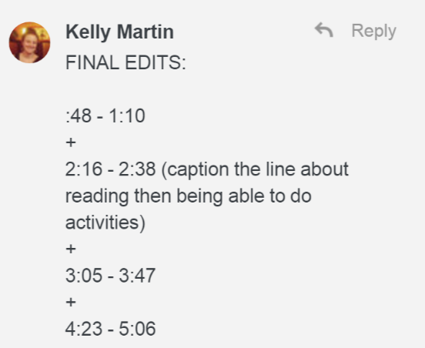

Split around 1:45

Split around 2:50

Split around 4:00

This will give us 4 separate clips that we can individually trim.

Trimming Videos: This tool is used to cut down the videos to the specific points we want. There are two ways to go about trimming the videos.

First, go to
Edit Trim Tool
Then, either
- Enter the start and end time in seconds
- Move the grey bars on the bottom of the clip to the appropriate points

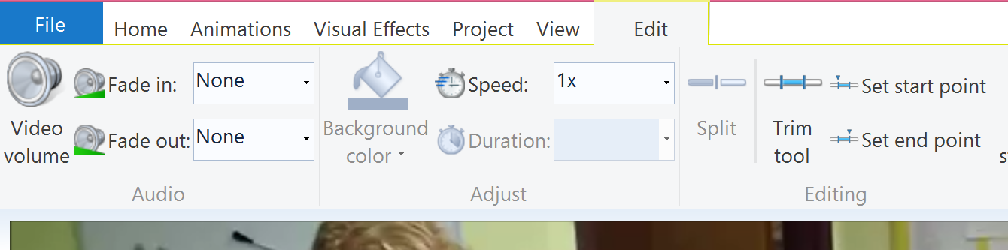

Trimming Videos (cont.):

Second, drag the bar along the video board, on the right, to the starting location and go to:
Edit Set start point
Then, drag the bar along the video board, on the right, to the ending location and go to:
Edit Set end point

TIPS:
- Use the exact seconds in the editing instructions as a guide, but of course use common sense (i.e. if we are trying to capture a specific sentence someone is saying and we need to extend the trim by a second or two, then extend it to get the sentence in)
- Work backwards in regards to the trims – start from the end of the clip and do the last trim and work forward – this will keep the time stamps matched up correctly for the remaining trims

Adding Transitions: This tool allows for better transitions between the split and trimmed videos so that the screen does not go blank and then start another clip, but easily moves into the next clip.

We use some fancier transitions to show that some time has lapsed between the two clips, and we use minimal distraction transitions (like blurry fades) to transition between most clips.

Drag the bar along the video board, on the right, to the location where the video clips are split and then go to:
Animations
Then, choose which transition to apply to the clips.
The same transition can be applied to all cuts by clicking ‘Apply to all’ after a specific transition is chosen.
The length of the transition can also be adjusted by changing the time in the ‘Duration’ box. Typically, transitions should be around 0.50

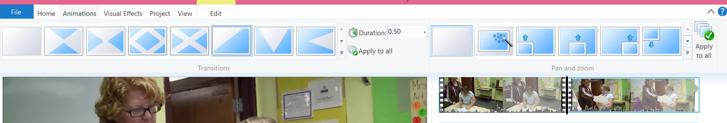

Adding Captions: This is one of the most important tools for our editing purposes since we want to ensure the interaction is understandable.

Drag the bar along the video board, on the right, to the location where the caption(s) need to be inserted, and then go to:
Home Captions

The caption can then be typed in the text box that appears on the movie screen.

It is important to make sure the text is visible on the screen. Typically, the text is white and can be moved around the screen to ensure it is properly visible. But, if white text is not visible on the screen, the text color can be changed by clicking on the circled A in the Font section and choosing the black font color.

To change how long the caption stays on the screen, choose the appropriate time from the drop down menu on ‘Text duration.’

It is also possible to change the start time of the caption by moving the individual pink caption, located on the bottom of the clips on the video board (on the right of the screen), to the left or right. Or the start time can be changed by changing the seconds in ‘Start time.’

NOTE: Add captions to the best of your ability, even if it is partially guessing or you have to put an occasional [inaudible]

Saving: There are two different saving methods – one to save the project and one to finalize the video.

Saving the project allows you to continue edits at a future time, go to:
File Save Project As
This saves the project as a Windows Movie Maker file and is NOT a playable format.

Therefore, to save the final video clip in order to be uploaded to Box for the workshops, go to:
Home Save movie Recommended for this project OR For computer
Save the final video clip as: Staff Name_FINAL --- This saves it as a movie that is playable. It’s a good idea to double check that you have saved the file as a playable movie by making sure that you can open the file using a media player (e.g., Windows MediaPlayer, VLC, etc.) —NOT just re-opening it in MovieMaker -- and that you can watch/hear the movie.

